**19CSE301- COMPUTER NETWORK**

**Case Study: Accident detection**

**Group No: 16**

|  |  |  |
| --- | --- | --- |
| **Group Member_ Roll No** | **Name** | **Department** |
| 16**_**CB.EN.U4CSE19007 | SURYA A | ADMINISTRATION, POLICE |
| 16**_**CB.EN.U4CSE19016 | TARUN SIVA SAI G | REGISTRATION |
| 16**_**CB.EN.U4CSE19041 | SAI KRISHNA P | HOSPITAL |

**Case study**

|  |  |  |
| --- | --- | --- |
| **Topic** | **Page No in the document** | **Supporting file name** |
| Problem Statement | **2** |  |
| Objective of the case study | **4** |  |
| Network Architecture Diagram | **14** |  |
| Performance Parameters | **12** |  |
| Department Details in the case study with description | **15** |  |
| Subnet ip scheme followed  [Solving the IP address allocation process for each subnetwork ] | **17** |  |
| Socket programming | **6-11** | **server_hosp.py**  **client_hosp_1.py**  **Patient.csv**  **Male_Patient.csv**  **Female_Patient.csv** |
| Cisco packet tracer – Application layer protocols | **20** |  |
| Cisco packet tracer – Virtual Local Area Network | **18,23** | **case_study_CSE19041(RIP&VLAN).pkt** |
| Cisco packet tracer – OSPF | **23** | **case_study_CSE19041(OSPF&VLAN).pkt** |
| Cisco packet tracer – RIP | **18** | **case_study_CSE19041(RIP&VLAN).pkt** |
| GoBack N and Selective Repeat protocol | **26** |  |
| Cloud concepts | **31** |  |
| How is cloud related to your application? | **32** |  |

**Problem Statement:**Day by Day accidents are increasing and we are losing peoples because of not getting medical help in time due to lack of intimation.so, to solve this problem Networking came into the picture, with the help of Networking we can help most of people to get medical help in time, so that the risk of losing lives can be decreased.

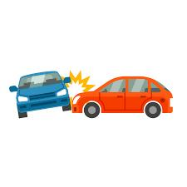

**Why Networking is required for the application:**

Road accident is one of the major concerns nowadays because vehicles in the roads are increasing day by day and still there is the use of traditional traffic management.

The motor vehicle population is growing at a faster

rate than the economic and population growth. Accidents and

the death rate due to road accidents, especially two wheelers

are also increasing at an alarming rate. Most of the accident

deaths that happens are due to the lack of immediate medical

assistance, on the roads like express highways. A facility for

providing immediate medical assistance to the accident area

can reduce the fatality to a greater extend. Thus comes the idea

of an alert system that senses the accident and its seriousness to

alert the nearby medical center for providing ambulance or

medical aid to the accident area

The motor vehicle population is growing at a faster

rate than the economic and population growth. Accidents and

the death rate due to road accidents, especially two wheelers

are also increasing at an alarming rate. Most of the accident

deaths that happens are due to the lack of immediate medical

assistance, on the roads like express highways. A facility for

providing immediate medical assistance to the accident area

can reduce the fatality to a greater extend. Thus comes the idea

of an alert system that senses the accident and its seriousness to

alert the nearby medical center for providing ambulance or

medical aid to the accident area

The motor vehicle population is growing at a faster

rate than the economic and population growth. Accidents and

the death rate due to road accidents, especially two wheelers

are also increasing at an alarming rate. Most of the accident

deaths that happens are due to the lack of immediate medical

assistance, on the roads like express highways. A facility for

providing immediate medical assistance to the accident area

can reduce the fatality to a greater extend. Thus comes the idea

of an alert system that senses the accident and its seriousness to

alert the nearby medical center for providing ambulance or

medical aid to the accident ar

The motor vehicle population is growing at a faster

rate than the economic and population growth. Accidents and

the death rate due to road accidents, especially two wheelers

are also increasing at an alarming rate. Most of the accident

deaths that happens are due to the lack of immediate medical

assistance, on the roads like express highways. A facility for

providing immediate medical assistance to the accident area

can reduce the fatality to a greater extend. Thus comes the idea

of an alert system that senses the accident and its seriousness to

alert the nearby medical center for providing ambulance or

medical aid to the accident area

The motor vehicle population is growing at a faster

rate than the economic and population growth. Accidents and

the death rate due to road accidents, especially two wheelers

are also increasing at an alarming rate. Most of the accident

deaths that happens are due to the lack of immediate medical

assistance, on the roads like express highways. A facility for

providing immediate medical assistance to the accident area

can reduce the fatality to a greater extend. Thus comes the idea

of an alert system that senses the accident and its seriousness to

alert the nearby medical center for providing ambulance or

medical aid to the accident area

Now-a-Days, the motor vehicle population is growing at a faster rate than the economic and population growth. Accidents and the death rate due to road accidents, especially two wheelers are also increasing at an alarming rate. Most of the accident deaths that happens are due to the lack of immediate medical assistance, on the roads like express highways. A facility for providing immediate medical assistance to the accident area can reduce the fatality to a greater extend. Thus comes the idea of an alert system that senses the accident and its seriousness to alert the nearby medical center for providing ambulance or medical aid to the accident area.

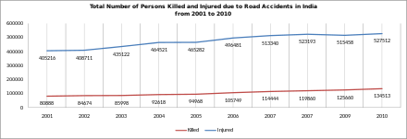

The Device we used in automobiles is OBD(“On Board Diagnostics “).

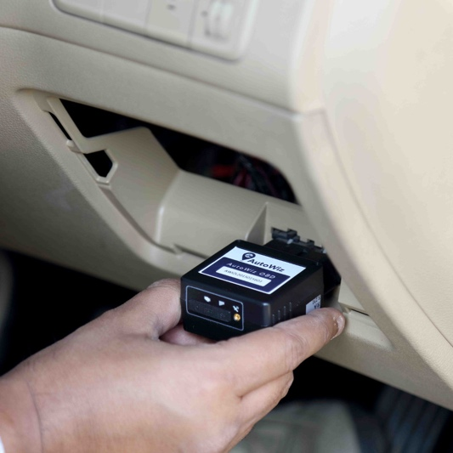

About OBD:

1. It’s the standardized system that allows external electronics to interface with a car’s computer system.
2. It has become more important as cars have become increasingly computerized, and software has become the key to fixing many problems and unlocking performance
3. OBD has existed in various forms long before anyone ever uttered the words “infotainment” or “connected car.”
4. It came about primarily because of two factors: The need to regulate emissions, and the mass adoption of electronic fuel injection by automakers beginning in the 1980s.

Benefits of OBD:

1. Inexpensive option as opposed to GPS tracking software
2. Enhance fleet and driver’s safety
3. Early Diagnosing of malfunctioning becomes handy
4. Increase the probability of DIY fix
5. Easiness and flexibility that comes with installation

Protocols in OBD:

1. SAE J1850 VPW: This OBD2 protocol is used by Ford.
2. SAE J1850 PWM: Common Motors utilize this protocol.
3. ISO 9141-2: You will find this protocol on Asian, Chrysler, and European cars.
4. ISO 14230 KWP2000: This protocol is found in Asian vehicles.
5. ISO 15765-4/SAE J2480 (CAN)

OBD2 Connector:

1. The OBD2 connector lets you access data from your car easily. The standard SAE J1962 specifies two female OBD2 16-pin connector types (A & B)
2. The OBD2 connector is near your steering wheel, but may be hidden behind covers/panels
3. Not all male connectors fit all OBD2 female sockets - check the type and OBD port pin-outs
4. Pin 16 supplies power via the car battery - often also while the ignition is off
5. Pins 6 (CAN-H) and 14 (CAN-L) are most relevant as CAN (ISO 15765-4) is
6. standard in most modern cars (incl. EVs)

**Devlopment of OBD2 in these years.:**

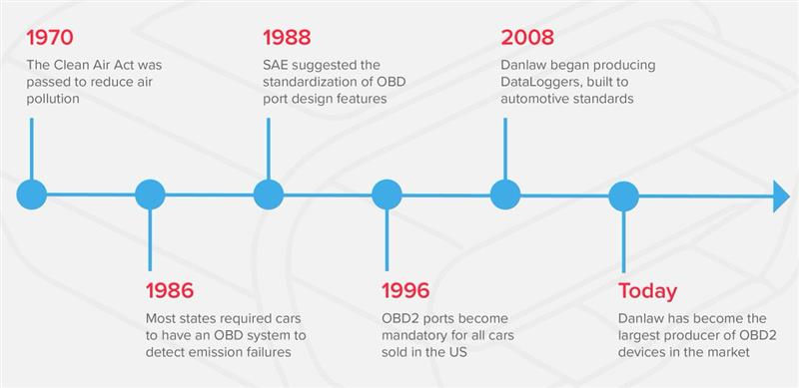

**Protocols Used in OBD:**

* TCP
* Internet protocol

**How OBDII can find it is an accident:-**

* Seat bags opening
* Petrol leakage

**Speed limit shardware parts used :-**

1.ARM

2. Fuel level sensor

3. Temperature sensor

4. Accelerometer sensor

5. GPS module

6. GSM module

7. Bluetooth

8.sd card

**Detail of OBD_ID’s**

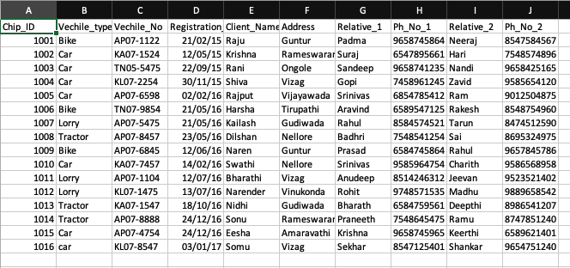

**Code for Server and Client:-**

* Hospital

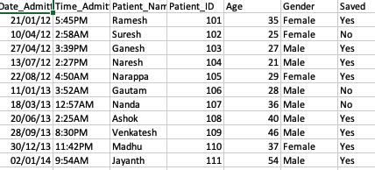

SERVER CODE:

import socket  
import pandas as pd  
from _thread import *  
S = socket.socket(socket.AF_INET, socket.SOCK_STREAM)  
port = 1224  
ThreadCount = 0  
try:  
 S.bind((socket.gethostname(), port))  
except socket.error as e:  
 print(str(e))  
print('Waiting for a Connection..')  
S.listen(10)  
  
def threaded_client(client):  
 client.send(str.encode('Welcome to the Server\n'))  
 client.send(str.encode('We got an accident detected at our area\n go there immediately'))  
 s = client.recv(1024).decode("utf-8")  
 print(s)  
 client.send(bytes("Select you option\nI.Insertion\nV-View\nD-Divide into different files\n", "utf-8"))  
 ch = client.recv(10).decode("utf-8")  
 if ch == 'I':  
 n = client.recv(10).decode("utf-8")  
 for i in range(1, int(n) + 1):  
 client.send(bytes("Enter Date_Admitted", "utf-8"))  
 Date_Admitted = client.recv(1000).decode("utf-8")  
 client.send(bytes("Enter Time_Admitted", "utf-8"))  
 Time_Admitted = client.recv(1000).decode("utf-8")  
 client.send(bytes("Enter Patient_ID :", "utf-8"))  
 client.send(bytes("Enter Patient_Name", "utf-8"))  
 Patient_Name = client.recv(1000).decode("utf-8")  
 Patient_ID = client.recv(1000).decode("utf-8")  
 client.send(bytes("Enter Age :", "utf-8"))  
 Age = client.recv(1000).decode("utf-8")  
 client.send(bytes("Enter Gender :", "utf-8"))  
 Gender = client.recv(1000).decode("utf-8")  
 client.send(bytes("Enter yes if we Saved the patient or not :", "utf-8"))  
 Saved = client.recv(1000).decode("utf-8")  
 list1 = [[Date_Admitted,Time_Admitted,Patient_Name,Patient_ID,Age,Gender,Saved]]  
 df2 = pd.DataFrame(list1,columns=['Date_Admitted','Time_Admitted','Patient_Name','Patient_ID','Age','Gender','Saved'])  
 df2.to_csv(r'/Users/saikrishnapaila/Desktop/Hospital_dept/Patient.csv', mode='a', index=False, header=False)  
  
 elif ch == 'V':  
 client.send(bytes("/Users/saikrishnapaila/Desktop/Hospital_dept/Patient.csv", "utf-8"))  
  
  
  
while True:  
 client, addr = S.accept()  
 print(f"Connection established to {addr} ")  
 start_new_thread(threaded_client, (client,))  
 ThreadCount += 1  
 print('Thread Number: ' + str(ThreadCount))

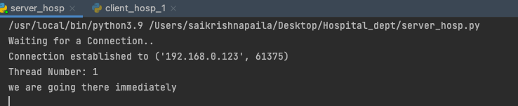

CLIENT CODE:

import socket  
import pandas as pd  
  
c = socket.socket(socket.AF_INET, socket.SOCK_STREAM)  
port = 1224  
print('Waiting for connection')  
try:  
 c.connect((socket.gethostname(), port))  
except socket.error as e:  
 print(str(e))  
  
Response = c.recv(1024).decode('utf-8')  
print(Response)  
cl = c.recv(1000).decode("utf-8")  
print(cl)  
c.send(bytes("we are going there immediately".encode("utf-8")))  
cl = input(c.recv(1000).decode("utf-8"))  
c.send(cl.encode("utf-8"))  
if cl == 'I':  
 n = int(input("Enter number of rows to be inserted : "))  
 c.send(str(n).encode("utf-8"))  
 for i in range(1, n + 1):  
 Date_Admitted = input(c.recv(1000).decode("utf-8"))  
 c.send(Date_Admitted.encode("utf-8"))  
 Time_Admitted = input(c.recv(1000).decode("utf-8"))  
 c.send(Time_Admitted.encode("utf-8"))  
 Patient_Name = input(c.recv(1000).decode("utf-8"))  
 c.send(Patient_Name.encode("utf-8"))  
 Patient_ID = input(c.recv(1000).decode("utf-8"))  
 c.send(Patient_ID.encode("utf-8"))  
 Age = input(c.recv(1000).decode("utf-8"))  
 c.send(Age.encode("utf-8"))  
 Gender = input(c.recv(1000).decode("utf-8"))  
 c.send(Gender.encode("utf-8"))  
 Saved = input(c.recv(1000).decode("utf-8"))  
 c.send(Saved.encode("utf-8"))  
  
elif cl == 'V':  
 print(pd.read_csv(c.recv(5000).decode("utf-8")))  
  
elif cl == 'D':  
 df = pd.read_csv(r'/Users/saikrishnapaila/Desktop/Hospital_dept/Patient.csv')  
 pat1 = df[df['Gender'] == 'Male']  
 pat1.to_csv(r'/Users/saikrishnapaila/Desktop/Hospital_dept/Male_Patient.csv', index=False)  
 print(pd.read_csv(r'/Users/saikrishnapaila/Desktop/Hospital_dept/Male_Patient.csv'))  
 pat2 = df[df['Gender'] == 'Female']  
 pat2.to_csv(r'/Users/saikrishnapaila/Desktop/Hospital_dept/Female_Patient.csv', index=False)  
 print(pd.read_csv(r'/Users/saikrishnapaila/Desktop/Hospital_dept/Female_Patient.csv'))  
  
  
  
  
  
c.close()

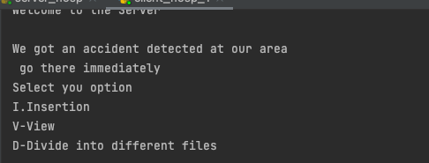

Function:

V-View

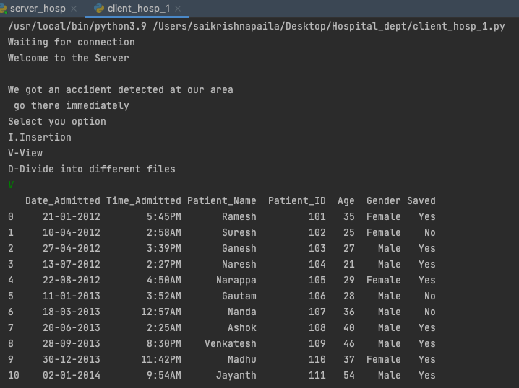

D-Divide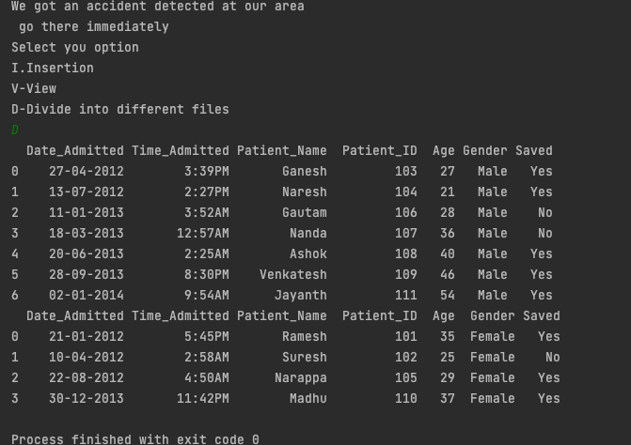

MALE:

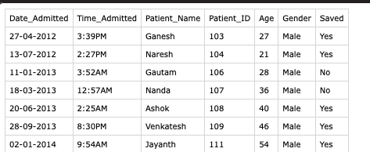

FEMALE:

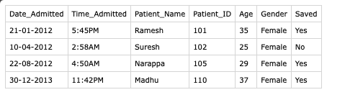

I-Insert:  
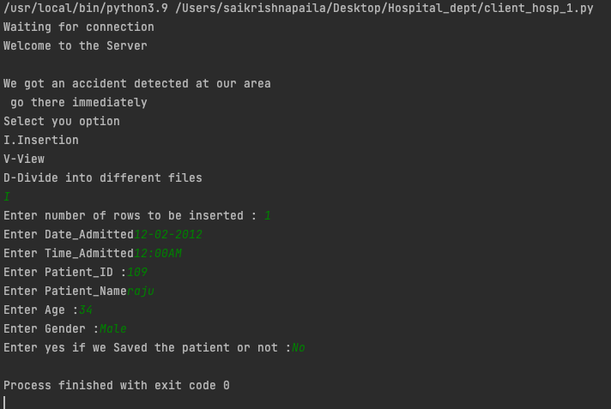

After Update:

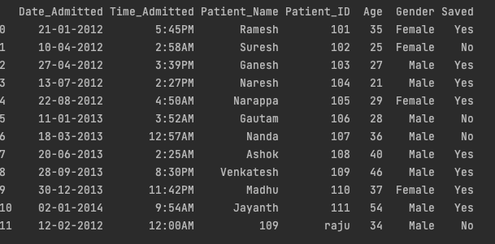

Analytical questions:

● Which of the following describes the creation of private networks across the Internet, enabling privacy and tunneling of non-TCP/IP protocols?

● How does a network topology affect your decision to set a network?

● What is the importance of implementing a Fault Tolerance System?

● What is the disadvantage of a star topology?

● When it comes to networking, what are rights?

● How does one prevent bottlenecks in the network, i.e., manage flow control?

● Quantify the scalability of the network - i.e, when more users connect, does the network suffer?

**Performance parameters:**

|  |  |  |
| --- | --- | --- |
| **Parameter** | **Meaning** | **Formula** |
| **Bandwidth** | Bandwidth is the capacity of a wired or wireless network communications link to transmit the maximum amount of data from one point to another over a computer network or internet connection in a given amount of time | Expressed as [bits](https://web.archive.org/web/20190816003233/https:/whatis.techtarget.com/definition/bit-binary-digit) per second ([bps](https://web.archive.org/web/20190816003233/https:/searchnetworking.techtarget.com/definition/bits-per-second)), modern network links have greater capacity, which is typically measured in millions of bits per second ([megabits per second](https://web.archive.org/web/20190816003233/https:/searchnetworking.techtarget.com/definition/Mbps), or Mbps) or billions of bits per second ([gigabits per second](https://web.archive.org/web/20190816003233/https:/whatis.techtarget.com/definition/Gbps-billions-of-bits-per-second), or Gbps). |
| **Throughput** | Throughput measures the percentage of data packets that are successfully being sent; a low throughput means there are a lot of failed or dropped packets that need to be sent again. | File Size/Time |
| **Packet Loss** | Packet loss occurs when one or more packets of data travelling across a computer network fail to reach their destination.Due to network congestion | Efficiency = 100% * (transferred - retransmitted) / transferred  Network Loss = 100 - Efficiency |
| **Transmission time** | The time required for transmission of a message depends on the size of the message and the bandwidth of the channel. | Transmission time=Message size / Bandwidth |
| **Propagation Time** | Propagation time measures the time required for a bit to travel from the source to the destination. The propagation time is calculated by dividing the distance by the propagation speed. | Propagation time = Distance /Propagation speed |
| **Processing Delay** | Time taken by the processor to process the data packet is called processing delay. | Directly proportional to processing speed of the routers. |
| **Queuing Delay** | Time spent by the data packet waiting in the queue before it is taken for execution is called queuing delay. | Directly Proportional to the congestion in the network |
| **Jitter** | Jitter is defined as the variation in time delay for the data packets sent over a network. This variable represents an identified disruption in the normal sequencing of data packets. Jitter is related to latency, since the jitter manifests itself in increased or uneven latency between data packets, which can disrupt network performance and lead to packet loss and network congestion. Although some level of jitter is to be expected and can usually be tolerated, quantifying network jitter is an important aspect of comprehensive network | Latency=sum of all delays    To measure Jitter, we take the difference between samples, then divide by the number of samples (minus 1). |

**Architecture diagram:**

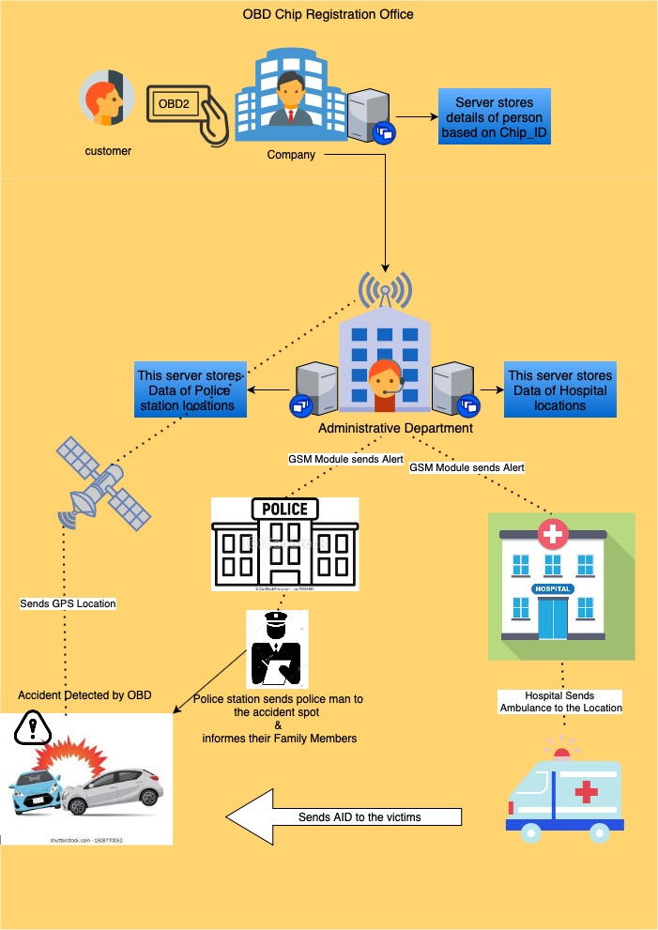

CISCO PACKET TRACER

|  |  |  |
| --- | --- | --- |
| **Department Name** | **Purpose** | **Network Details**  **(No of nodes, servers, Protocols)** |
| REGISTRATION | the purpose of this department is, user can register the obd chip along with his/her vehicles following with user details. Here the user details will be stored in server and sent to  administration department. | No of nodes = 27  No of servers = 3  Type of servers = Email, Dns  Protocols used = OSPF, RIP, VLAN |
| ADMINISTRATION | the main purpose of this department is, after the accident is detected through the satellites  signal (details of obd chip) will come to the server. After the signal is reached the details will be  checked with the database and we will extract the user details and relative details.  it will send the details to hospital and police server and inform to user's relatives. | No of nodes = 16  No of servers = 3  Type of servers = FTP, EMAIL, DNS  Protocols used = OSPF, RIP, VLAN |
| POLICE | the main purpose of this department is, after receiving the details (place of accident) of user from administration server  A couple of police officers will be sent to the accident spot and they will collect the details and samples  of how it happened and case a FIR on the accident case. | No of nodes = 16  No of servers = 3  Type of servers = FTP, EMAIL, DNS  Protocols used = OSPF, RIP, VLAN |
| HOSPITAL | the main purpose of this department is, after receiving the details (place of accident) of user from administration server  An ambulance will be sent to the place of accident to perform the first aid and shift the patient to hospital.  they will take all necessary actions to save the victim. | No of nodes = 12  No of servers = 2  Type of servers = DNS, FTP  Protocols used = VLAN, OSPF, RIP |

Routing Protocol used:

RIP

VLAN

OSPF

RIP & VLAN Packet screenshot:

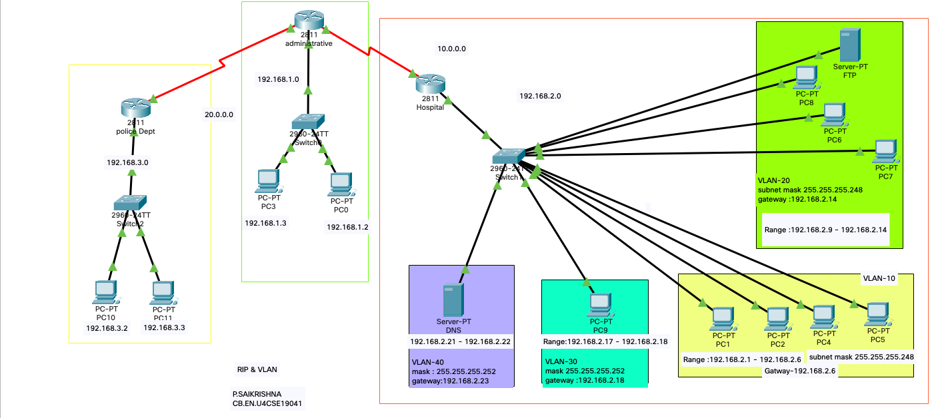

Running outputs:

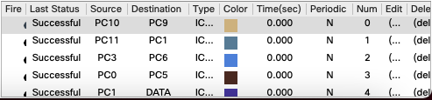

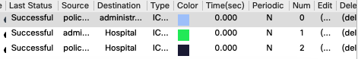

Ip address :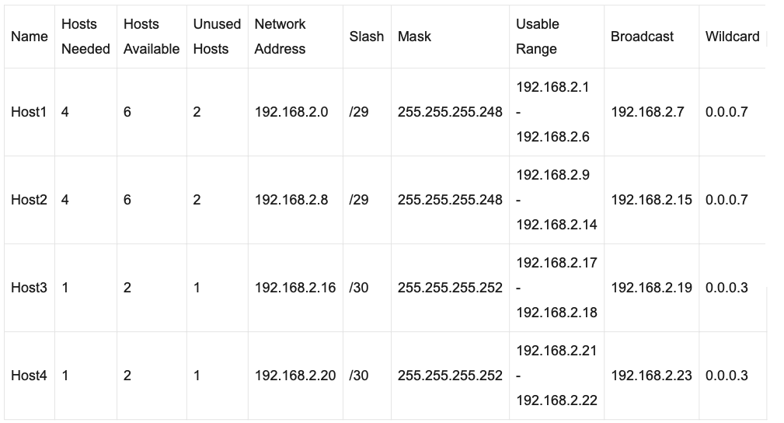

Host-1

IP address (192.168.2.1 - 192.168.2.6)-

11000000.10101000.00000010.00000001- 11000000.10101000.00000010.00000110

Host-2

IP address (192.168.2.9 - 192.168.2.14)-

11000000.10101000.00000010.00001001 - 11000000.10101000.00000010.00001110

Host-3

IP address (192.168.2.17 - 192.168.2.18)-

11000000.10101000.00000010.00010001 - 11000000.10101000.00000010.00010010

Host-4

IP address (192.168.2.21 - 192.168.2.22)-

11000000.10101000.00000010.00010101 - 11000000.10101000.00000010.00010110

Subnet mask (255.255.255.248)- 11111111.11111111.11111111.11111000

Subnet mask (255.255.255.252)- 11111111.11111111.11111111.11111100

The network address (192.168.2.0)- 11000000.10101000.00000010. 0000000

Host address (000.000.000.1- 000.000.000.6)

00000000.00000000.00000000.00000001 - 00000000.00000000.00000000.00000110

RIP screenshots:

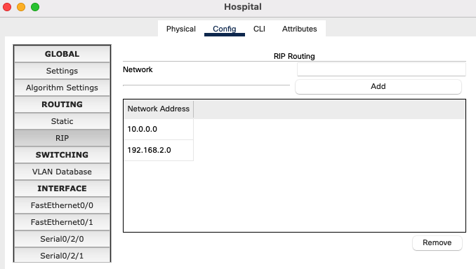

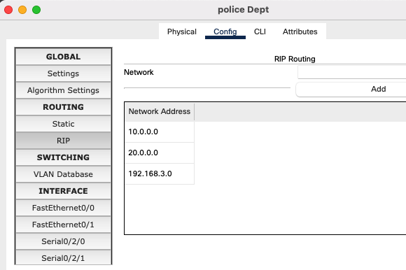

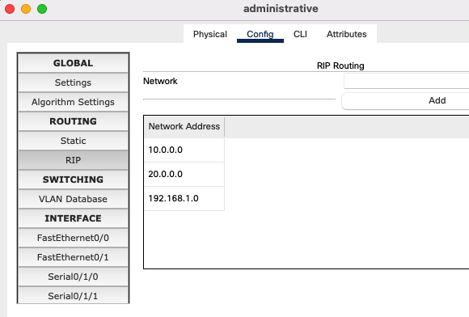

VLAN screenshots:

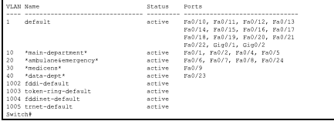

Command prompt: ping command

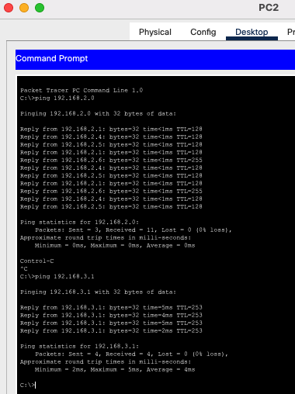

FTP:

FTP means "**File Transfer Protocol**" and refers to a group of rules that govern how computers transfer files from one system to another

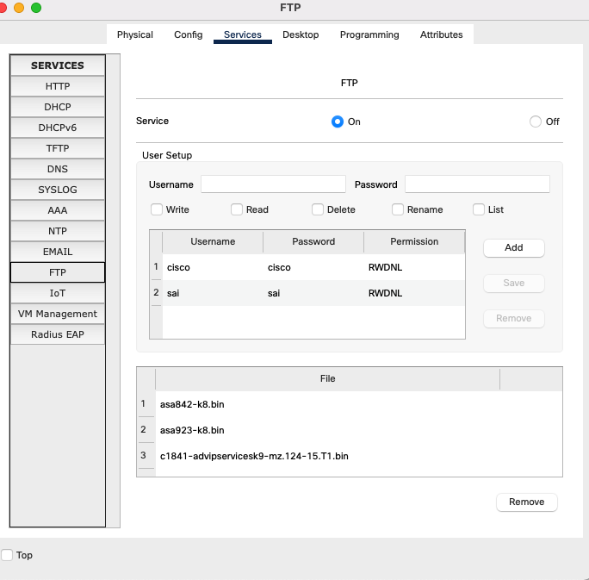

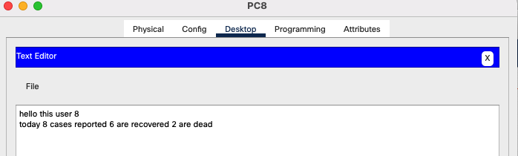

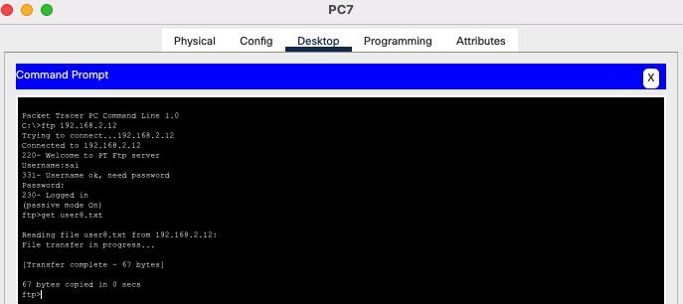

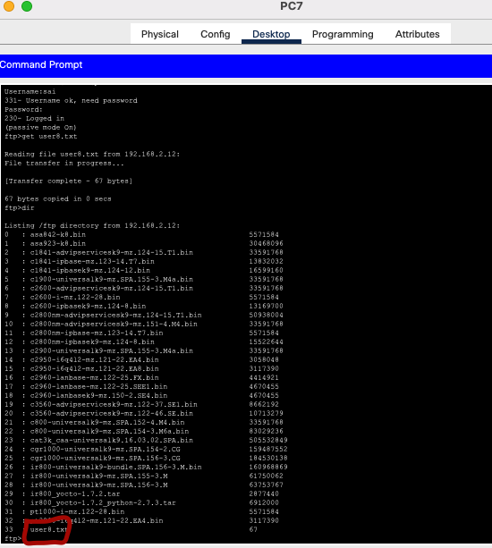

DNS server:

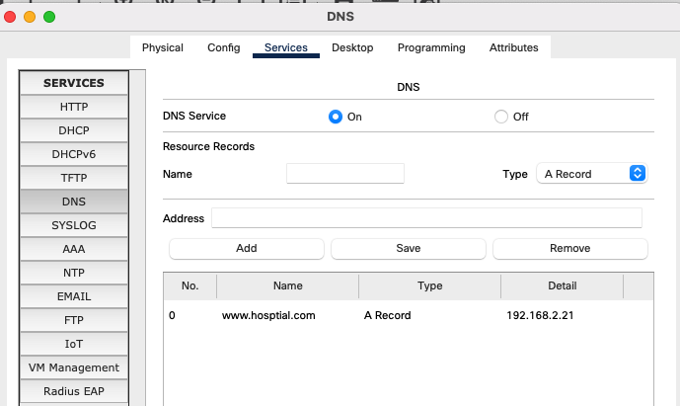

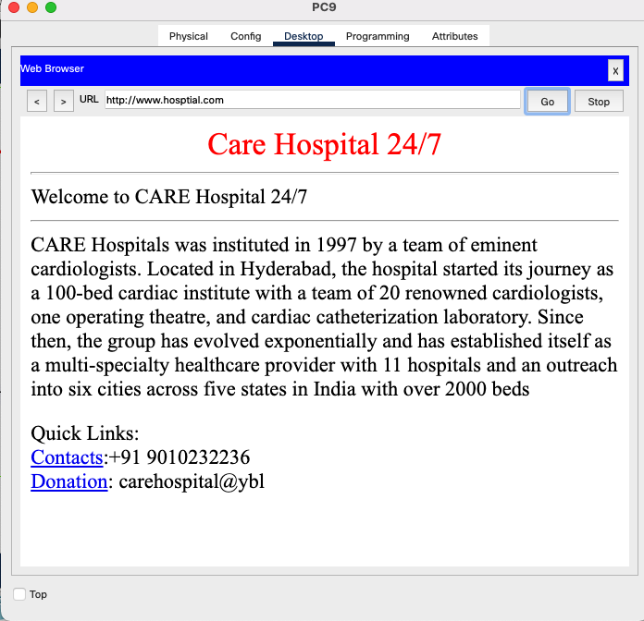

OSPF & VLAN :

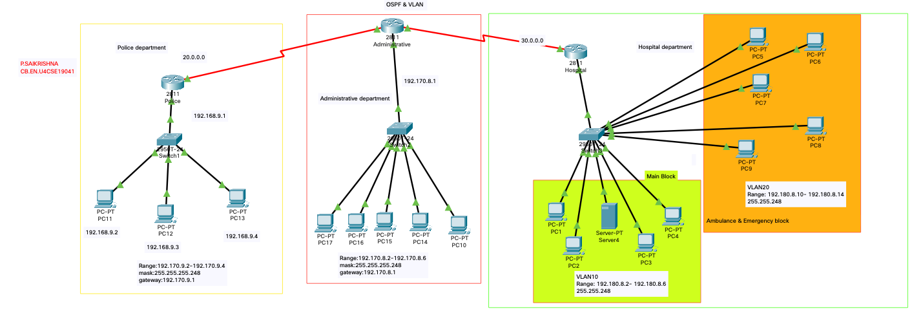

Running output:

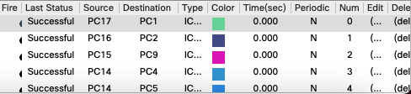

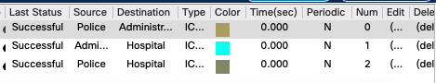

IP address:

Hospital department:

VLAN10:

Range: 192.180.8.2- 192.180.8.6

Subnet mask -255.255.248

Gateway- 192.180.8.1

VLAN20:

Range: 192.180.8.10- 192.180.8.14

Subnet mask -255.255.248

Gateway- 192.180.8.10

Administrative department:

Range:192.170.8.2-192.170.8.6

Subnet mask:255.255.255.248

gateway:192.170.8.1

Police Department:

Range:192.170.9.2-192.170.9.4

mask:255.255.255.248

gateway:192.170.9.1

OSPF:

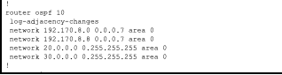

Router screenshots:

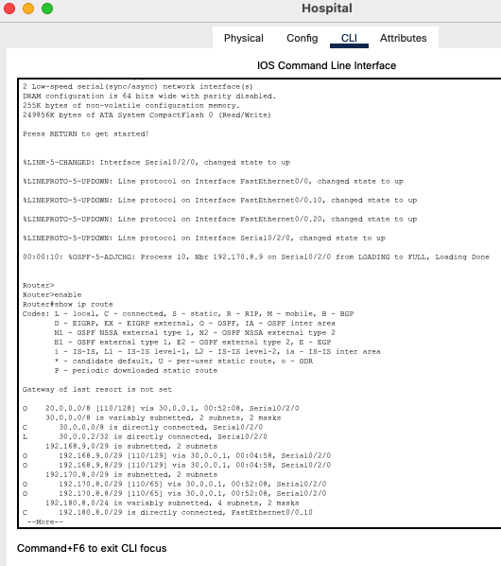

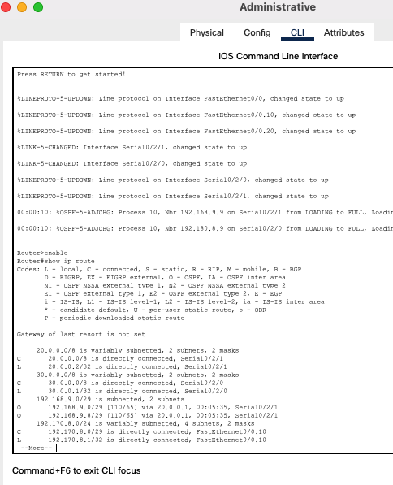

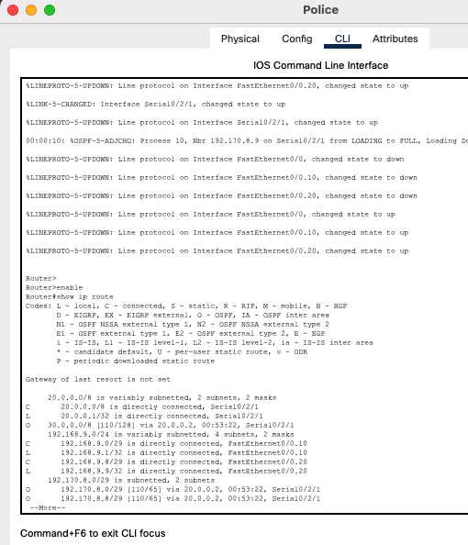

GO BACKEND AND SELECTIVE REPEAT CODES

**GO BACK N SELECTIVE REPEAT**

**SERVER.JAVA**

**import java.io.DataInputStream;**

**import java.io.DataOutputStream;**

**import java.io.IOException;**

**import java.net.ServerSocket;**

**import java.net.Socket;**

**import java.net.SocketException;**

**public class Server {**

**static ServerSocket Serversocket;**

**static DataInputStream dis;**

**static DataOutputStream dos;**

**public static void main(String[] args) throws SocketException {**

**try {**

**int a[] = { 4,8,12,16,20,24,28,32,36 };**

**Serversocket = new ServerSocket(8011);**

**System.out.println("waiting for connection");**

**Socket client = Serversocket.accept();**

**dis = new DataInputStream(client.getInputStream());**

**dos = new DataOutputStream(client.getOutputStream());**

**System.out.println("The number of packets sent is:" + a.length);**

**int y = a.length;**

**dos.write(y);**

**dos.flush();**

**for (int i = 0; i < a.length; i++) {**

**dos.write(a[i]);**

**dos.flush();**

**}**

**int k = dis.read();**

**dos.write(a[k]);**

**dos.flush();**

**} catch (IOException e) {**

**System.out.println(e);**

**} finally {**

**try {**

**dis.close();**

**dos.close();**

**} catch (IOException e) {**

**// TODO Auto-generated catch block**

**e.printStackTrace();**

**}**

**}**

**}**

**}**

**CLIENT.JAVA**

**import java.lang.System;**

**import java.net.*;**

**import java.io.*;**

**public class Client {**

**static Socket connection;**

**public static void main(String a[]) throws SocketException {**

**try {**

**int v[] = new int[9];**

**//int g[] = new int[8];**

**int n = 0;**

**InetAddress addr = InetAddress.getByName("Localhost");**

**System.out.println(addr);**

**connection = new Socket(addr, 8011);**

**DataOutputStream out = new DataOutputStream(**

**connection.getOutputStream());**

**DataInputStream in = new DataInputStream(**

**connection.getInputStream());**

**int p = in.read();**

**System.out.println("No of frame is:" + p);**

**for (int i = 0; i < p; i++) {**

**v[i] = in.read();**

**System.out.println(v[i]);**

**//g[i] = v[i];**

**}**

**v[0] = -1;**

**for (int i = 0; i < p; i++)**

**{**

**System.out.println("Received frame is: " + v[i]);**

**}**

**for (int i = 0; i < p; i++)**

**if (v[i] == -1) {**

**System.out.println("Request to retransmit packet no "**

**+ (i+1) + " again!!");**

**n = i;**

**out.write(n);**

**out.flush();**

**}**

**System.out.println();**

**v[n] = in.read();**

**System.out.println("Received frame is: " + v[n]);**

**System.out.println("quiting");**

**} catch (Exception e) {**

**System.out.println(e);**

**}**

**}**

**}**

**OUTPUT**

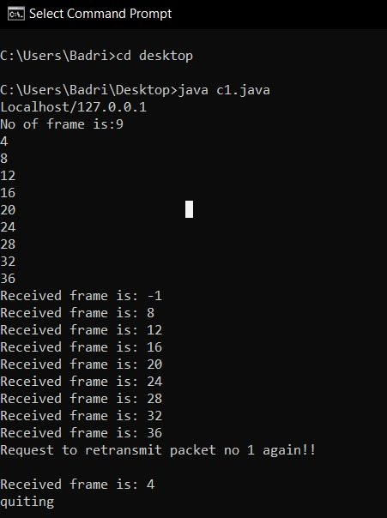

**Cloud computing**

Cloud computing is the delivery of different services through the Internet, including data storage, servers, databases, networking, and software. Cloud-based storage makes it possible to save files to a remote database and retrieve them on demand.

**Cloud computing in Accident Detection**

The increase in accidents is due to dynamic traffic conditions on roads in day-to-day life. we proposed an accident detection system model on IoT and the cloud. In this scenario, we suggest a model for accident detection, which will demonstrate crash avoidance and braking systems for the area of vehicle networks such as the intelligent transport system, which focuses on road safety and communication between on-road vehicles.

Every vehicle is equipped with ultrasonic wave beneficiary by that it will revert the ultrasonic wave motion from the obstruction, for blocking and isolating the vehicle reflected wave is to be measured. At this time, the servo engine based on cognition beat data is controlled using a PIC micro-controller, vehicle braking system was naturally monitored by the servo engine. However, using this technology two or four-wheeled vehicles will stop by detecting the obstacles to avoid an accident. A flag is provided to provide ultrasonic waves irregularly. By using an ultrasonic wave transmitter, it will send the waves to the front of the predetermined division, for detecting huge extreme ranged obstacles in here we are using ultrasonic sensors, due to the reason it can be recognized easily.

**Conclusion:**

While planning use of cloud computing initiatives in future for avoiding Accidents, we use ULTRASONIC TRANSMITTER in vehicles to detect that another vehicle or snag is approaching an impact and to stop the car as required, which is completed by the breaking circuit. The ultrasonic slowing mechanism focuses on the idea that vehicles must then brake when sensors are aware of the obstacle. This is more useful to people to avoid accidents.

The motor vehicle population is growing at a faster

rate than the economic and population growth. Accidents and

the death rate due to road accidents, especially two wheelers

are also increasing at an alarming rate. Most of the accident

deaths that happens are due to the lack of immediate medical

assistance, on the roads like express highways.

The motor vehicle population is growing at a faster

rate than the economic and population growth. Accidents and

the death rate due to road accidents, especially two wheelers

are also increasing at an alarming rate. Most of the accident

deaths that happens are due to the lack of immediate medical

assistance, on the roads like express highways.

The motor vehicle population is growing at a faster

rate than the economic and population growth. Accidents and

the death rate due to road accidents, especially two wheelers

are also increasing at an alarming rate. Most of the accident

deaths that happens are due to the lack of immediate medical

assistance, on the roads like express highways.

The motor vehicle population is growing at a faster

rate than the economic and population growth. Accidents and

the death rate due to road accidents, especially two wheelers

are also increasing at an alarming rate. Most of the accident

deaths that happens are due to the lack of immediate medical

assistance, on the roads like express highways. A facility for

providing immediate medical assistance to the accident area

can reduce the fatality to a greater extend. Thus comes the idea

of an alert system that senses the accident and its seriousness to

alert the nearby medical center for providing ambulance or

medical aid to the accident area.

The motor vehicle population is growing at a faster

rate than the economic and population growth. Accidents and

the death rate due to road accidents, especially two wheelers

are also increasing at an alarming rate. Most of the accident

deaths that happens are due to the lack of immediate medical

assistance, on the roads like express highways. A facility for

providing immediate medical assistance to the accident area

can reduce the fatality to a greater extend. Thus comes the idea

of an alert system that senses the accident and its seriousness to

alert the nearby medical center for providing ambulance or

medical aid to the accident area.

The motor vehicle population is growing at a faster

rate than the economic and population growth. Accidents and

the death rate due to road accidents, especially two wheelers

are also increasing at an alarming rate. Most of the accident

deaths that happens are due to the lack of immediate medical

assistance, on the roads like express highways. A facility for

providing immediate medical assistance to the accident area

can reduce the fatality to a greater extend. Thus comes the idea

of an alert system that senses the accident and its seriousness to

alert the nearby medical center for providing ambulance or

medical aid to the accident area.

The motor vehicle population is growing at a faster

rate than the economic and population growth. Accidents and

the death rate due to road accidents, especially two wheelers

are also increasing at an alarming rate. Most of the accident

deaths that happens are due to the lack of immediate medical

assistance, on the roads like express highways. A facility for

providing immediate medical assistance to the accident area

can reduce the fatality to a greater extend. Thus comes the idea

of an alert system that senses the accident and its seriousness to

alert the nearby medical center for providing ambulance or

medical aid to the accident area.

The motor vehicle population is growing at a faster

rate than the economic and population growth. Accidents and

the death rate due to road accidents, especially two wheelers

are also increasing at an alarming rate. Most of the accident

deaths that happens are due to the lack of immediate medical

assistance, on the roads like express highways. A facility for

providing immediate medical assistance to the accident area

can reduce the fatality to a greater extend. Thus comes the idea

of an alert system that senses the accident and its seriousness to

alert the nearby medical center for providing ambulance or

medical aid to the accident area.